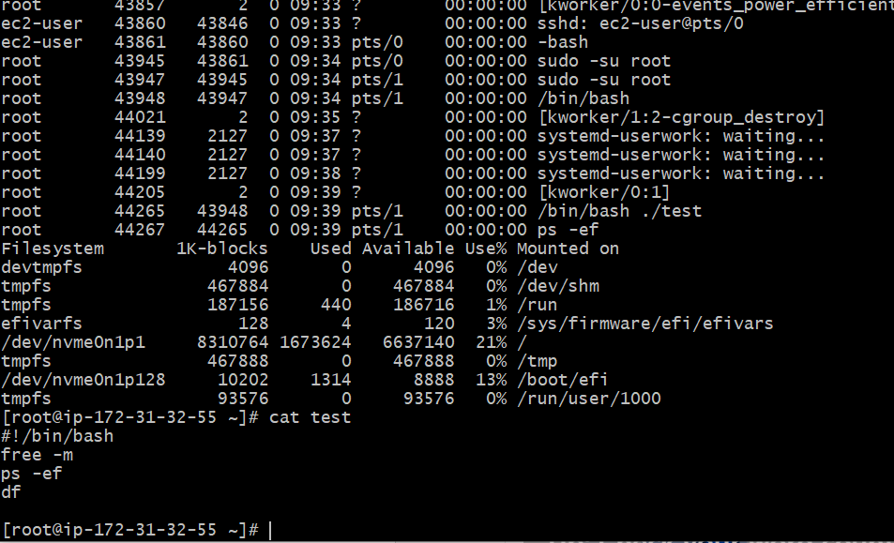

Above picture shows the how to make automatic the sanity test , means free -m, ps -ef running services, df disk free space

1. How to find the shell?

1. How to find the shell and how to swtich the shell

1. Above picture shows we have created the directory as Waseem and script then created script as helloworld

1. And we have executed the scripte with 2 ways thru ./script and bash helloworld

We created script as xyz and . /xyz it will ask for permission and to access without permission we can use the command as bash xyz, if want to provide permission chmod 777 xyz

In the above picture this we have done the scripts to better understand our script easily and have change the variables names helloworld to hellowaseem

7

We have created the script file as secondcommand.bash and ener the commands and gave chmod 755 and checked with ll

In this we have created script as Waseem and entered the top, df -h, free -m, uptime, iostat and executed the commands for output

We have created the script as mohd and entered variables as p, l, wi, d, c and ech run variables as $p, $l, $wi, $d, $c and executed the command as ./mohd and above is the output for that variables and commands

Here we have created the script as input.bash and enter name as hello my name is vaseem and in read $name as shoeb when we have gave command ./input.bash this is the output came